Reeksamen 2023
$$\overline{r}=\left(\begin{aligned}0.1 \\ 0.2\end{aligned}\right)$$
Q1
For asset 1
$${\overline{r}}_{1}=\frac{{\overline{P}}_{1}^{}(1)}{P_{0}}-1$$
We solve for $P_{0}$
$$0.1=\frac{220}{x}-1$$
$⇕$ Ligningen løses for x vha. WordMat.
$$P_{1}(0)=200$$
Same for asset 2
$$0.2=\frac{120}{x}-1$$
$⇕$ Ligningen løses for x vha. WordMat.
$$P_{2}(0)=100$$

Q2
$$σ_{1}^{2}={0.1}^{2}≈0,01$$
$$σ_{2}^{2}={0.3}^{2}=0,09$$
$$σ_{12}=σ_{1}·σ_{2}·ρ_{12}=0.1·0.3·0.5=0,015$$
Thus
$$Σ=\left(\begin{matrix}0.01 & 0.015 \\ 0.015 & 0.09\end{matrix}\right)$$
Q3
$$w_{m}=\left(\begin{aligned}0.30 \\ 0.70\end{aligned}\right)$$
$${\overline{r}}_{m}=transpose\left(\left(\begin{aligned}0.1 \\ 0.2\end{aligned}\right)\right)\left(\begin{aligned}0.30 \\ 0.70\end{aligned}\right)≈0,17$$
$$σ_{m}^{2}=transpose\left(\left(\begin{aligned}0.30 \\ 0.70\end{aligned}\right)\right)\left(\begin{matrix}0.01 & 0.015 \\ 0.015 & 0.09\end{matrix}\right)\left(\begin{aligned}0.30 \\ 0.70\end{aligned}\right)=0,0513$$
Q4
$$β=\frac{1}{σ_{m}^{2}}Σw_{m}$$
$$=\frac{1}{0,0513}\left(\begin{matrix}0.01 & 0.015 \\ 0.015 & 0.09\end{matrix}\right)\left(\begin{aligned}0.3 \\ 0.7\end{aligned}\right)≈\left(\begin{matrix}0,2631579 \\ 1,3157895\end{matrix}\right)$$
$$β_{1}=0.263$$
$$β_{2}=1.316$$
Q5 assuming the market is in CAPM EQ
Then the expected return of a portfolio with 0 beta must be the risk free rate
We find the zero beta portfolio
$$transpose\left(\left(\begin{aligned}α \\ 1-α\end{aligned}\right)\right)\left(\begin{matrix}0.01 & 0.015 \\ 0.015 & 0.09\end{matrix}\right)\left(\begin{aligned}0.3 \\ 0.7\end{aligned}\right)=0,0675-0,054·α$$
$$0,0675-0,054·α=0$$
$⇕$ Ligningen løses for α vha. WordMat.
$$α=1,25$$
$$w_{ZB}=\left(\begin{aligned}\frac{5}{4} \\ -\frac{1}{4}\end{aligned}\right)$$
Shortselling is allowed in the markowitx framework so this is fine
$${\overline{r}}_{ZB}=transpose\left(\left(\begin{aligned}0.1 \\ 0.2\end{aligned}\right)\right)\left(\begin{aligned}\frac{5}{4} \\ -\frac{1}{4}\end{aligned}\right)=0,075$$
Assuming capm is satisied then
$${\overline{r}}_{p}=r_{f}+β_{p}\left({\overline{r}}_{m}-r_{f}\right)$$
Since $β_{ZB}=0$
Then ${\overline{r}}_{ZB}=r_{f}=0.075$
Q6
Im assuming that we are able to invest in the risk free asset
Thus we would invest in the tangency portfolio and the risk free asset to minimize our risk this is the only way to make an efficient portfolio due to the one fund theorem
We dertermine the weights in the risk free asset and the market portfolio
$${\overline{r}}_{required}=α·{\overline{r}}_{m}+\left(1-α\right)·r_{f}$$
$$0.10=α·0.17+\left(1-α\right)·0.075$$
$⇕$
$$α=0,2631579$$
This would yield us the variance
$$α^{2}·σ_{tan}^{2}={0,2631579}^{2}·0,0513≈0,0035526<0.01=σ_{1}^{2}$$

This shows that we are able to get the same expected return with less risk

If we were to not use the risk free asset in the exercise then I would use the formula

$$w^{⋆}=\frac{a·{\overline{r}}_{p}-b}{d}Σ^{-1}\overline{r}+\frac{c-{\overline{r}}_{p}b}{d}Σ^{-1}I$$
With a,b,c and d being the usual when in the markowitz framework

Exercise 2
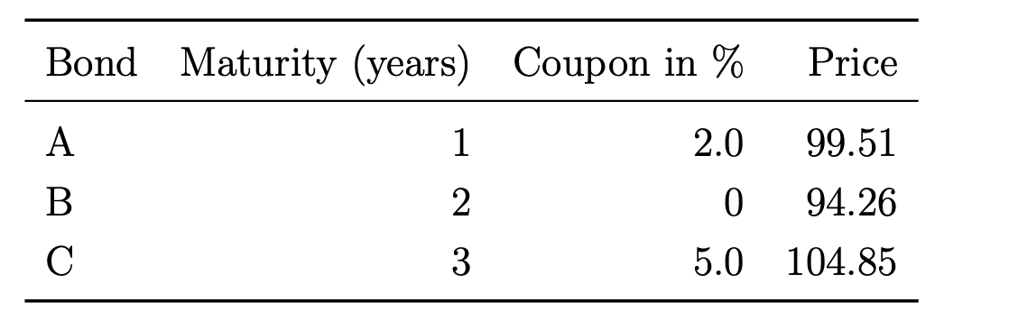
All cupon bonds
Q1
$$B=\left(\begin{matrix}102 & 0 & 0 \\ 0 & 100 & 0 \\ 5 & 5 & 105\end{matrix}\right)$$
$$P=\left(\begin{aligned}99.51 \\ 94.26 \\ 104.85\end{aligned}\right)$$
$$d={\left(\begin{matrix}102 & 0 & 0 \\ 0 & 100 & 0 \\ 5 & 5 & 105\end{matrix}\right)}^{-1}\left(\begin{aligned}99.51 \\ 94.26 \\ 104.85\end{aligned}\right)≈\left(\begin{matrix}0,9755882 \\ 0,9426 \\ 0,9072291\end{matrix}\right)$$
$$s_{1}=\frac{1}{0,9755882}-1≈0,0250226$$
$$s_{2}=\frac{1}{{0,9426}^{\frac{1}{2}}}-1≈0,0299978$$
$$s_{3}=\frac{1}{{0,9072291}^{\frac{1}{3}}}-1 ≈0,0329858$$
Q2
$$f_{1,2}=\frac{d_{1}}{d_{2}}-1=\frac{0,9755882}{0,9426}-1≈0,034997$$
$$f_{2,3}=\frac{d_{2}}{d_{3}}-1=\frac{0,9426}{0,9072291}-1≈0,0389878$$
$$f_{1,3}=\sqrt{\frac{d_{1}}{d_{3}}}-1=\sqrt{\frac{0,9755882}{0,9072291}}-1≈0,0369905$$

Q3

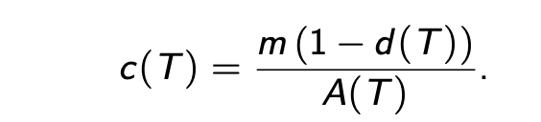
$$c\left(1\right)=\frac{1-0,9755882}{0,9755882}≈0,0250226$$
$$c\left(2\right)=\frac{1-0,9426}{0,9426+0,9755882}≈0,0299241$$
$$c\left(3\right)=\frac{1-0,9072291}{0,9072291+0,9426+0,9755882}≈0,0328344$$
Q4

New bond is introduced
$$B^{'}=\left(\begin{matrix}4 & 4 & 104\end{matrix}\right)$$
With a price of
$$P_{market}^{'}=101.54$$
We price the replication in our complete 3 bond market
$$P_{replication}^{'}=\left(\begin{matrix}4 & 4 & 104\end{matrix}\right)\left(\begin{matrix}0,9755882 \\ 0,9426 \\ 0,9072291\end{matrix}\right)=102,0245792$$
We note that the bond is to cheap in the market, so we replicate the bond
$$θ=\left(\begin{matrix}4 & 4 & 104\end{matrix}\right){\left(\begin{matrix}102 & 0 & 0 \\ 0 & 100 & 0 \\ 5 & 5 & 105\end{matrix}\right)}^{-1}=\left(\begin{matrix}-\left(\frac{10}{1071}\right) & -\left(\frac{1}{105}\right) & \frac{104}{105}\end{matrix}\right)≈\left(\begin{matrix}-0,0093371 & -0,0095238 & 0,9904762\end{matrix}\right)$$
Since $P_{replication}^{'}>P_{market}^{'}$ we buy low sell high thus we sell the replication and buy the one in the maket for a profit of $102,0245792-101.54≈0,4845792$ with no obligations in the future making an arbitrage

Q5+Q6 im computing first the duration and then the convexity of every bond
I calculate the yields
$$\frac{102}{1+λ}=99.51$$
$⇕$
$$λ=0,0250226$$

bond 2
$$\frac{100}{{\left(1+λ\right)}^{2}}=94.26$$
$⇕$
$$λ=0,0299978$$

bond 3
$$\frac{5}{1+λ}+\frac{5}{{\left(1+λ\right)}^{2}}+\frac{105}{{\left(1+λ\right)}^{3}}=104.85$$
$⇕$
$$λ=0,0327626$$

We have a general formula
$$D_{mod}=-\frac{dP}{dλ}·\frac{1}{P}=\frac{1}{P}·\frac{1}{1+\frac{λ}{m}}\sum_{k=1}^{n}{\frac{t_{k}·x_{k}}{{m·\left(1+\frac{λ}{m}\right)}^{t_{k}}}}$$
$$C=\frac{1}{P}·\frac{d^{2}P}{dλ^{2}}=\frac{1}{P}·\frac{1}{{\left(1+\frac{λ}{m}\right)}^{2}}\sum_{k=1}^{n}{\frac{t_{k}+1}{m}\frac{t_{k}}{m}\frac{x_{k}}{{\left(1+\frac{λ}{m}\right)}^{t_{k}}}}$$

Bond A
$$D_{A}=\frac{1}{99.51}·\frac{1}{1+0,0250226}·\frac{103}{1+0,0250226}≈0,9851528$$
$$C_{A}=\frac{1}{99.51}·\frac{1}{{\left(1+0,0250226\right)}^{2}}·\frac{102·2}{1+0,0250226}≈1,9035449$$
Bond B
$$D_{B}=\frac{1}{94.26}·\frac{1}{1+0,0299978}·2·\frac{100}{{\left(1+0,0299978\right)}^{2}}≈1,9417516$$
$$C_{B}=\frac{1}{94.26}·\frac{1}{{\left(1+0,0299978\right)}^{2}}·2·3·\frac{100}{{\left(1+0,0299978\right)}^{2}}≈5,6555992$$
Bond C

$$D_{c}=\frac{\frac{5}{1+0,0327626}+\frac{2·5}{{\left(1+0,0327626\right)}^{2}}+\frac{3·105}{{\left(1+0,0327626\right)}^{3}}}{104.85}·\frac{1}{1+0,0327626}≈2,77212$$
$$C_{c}=\frac{\frac{5·2}{1+0,0327626}+\frac{3·2·5}{{\left(1+0,0327626\right)}^{2}}+\frac{3·105·4}{{\left(1+0,0327626\right)}^{3}}}{104.85}\frac{1}{{\left(1+0,0327626\right)}^{2}}≈10,566299$$

Exercise 3

We do this with statepricing with our normal formulas
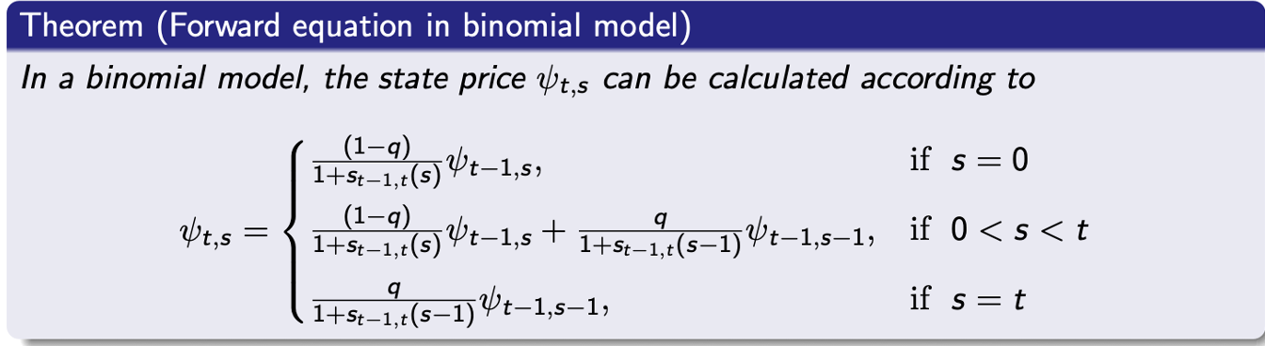
$$ψ_{0,0}=1$$
$$ψ_{1,0}=\frac{0.5}{1.01}≈0,4950495$$
$$ψ_{1,1}=\frac{0.5}{1.01}≈0,4950495$$
$$B_{0,1}=ψ_{1,0}+ψ_{1,1}=0,4950495+0,4950495=0,990099$$
$$ψ_{2,0}=\frac{0.5}{1.005}·0,4950495≈0,2462933$$
$$ψ_{2,1}=0.5·\frac{1}{1.005}·0,4950495+0.5·\frac{1}{1.02}·0,4950495≈0,4889646$$
$$ψ_{2,2}=0.5·\frac{1}{1.02}·0,4950495≈0,2426713$$
$$B_{0,2}=ψ_{2,0}+ψ_{2,1}+ψ_{2,2}=0,2462933+0,4889646+0,2426713=0,9779292$$
$$ψ_{3,0}=\frac{1}{1}·0,2462933=0,2462933$$
$$ψ_{3,1}=\frac{0,4889646}{1.01}≈0,4841234$$
$$ψ_{3,2}=\frac{0,2426713}{1.03}≈0,2356032$$
$$B_{0,3}=ψ_{3,0}+ψ_{3,1}+ψ_{3,2}=0,2462933+0,4841234+0,2356032≈0,9660199$$
In sumary
$$B_{0,1}=0,990099$$
$$B_{0,2}=0,9779292$$
$$B_{0,3}=0,9660199$$
Q2

The property of a fair forward price at time T
$$E^{Q}\left[d_{0,2}F_{2}-B_{0,3}·d_{0,2}\right]=0$$
$$⇒F_{2}E^{Q}\left[d_{0,T}\right]=E^{Q}[B_{0,3}·d_{0,2}]$$
$$F_{2}=\frac{E^{Q}\left[B_{0,3}·d_{0,2}\right]}{E^{Q}\left[d_{0,2}\right]}$$
But these are simply the value of ZCB
$$F_{2}=\frac{B_{0,3}}{B_{0,2}}=\frac{0,9660199}{0,9779292}≈0,9878219$$
Q3
We simply have a formula
$$c=\frac{1-B_{0,3}}{B_{0,1}+B_{0,2}+B_{0.3}}=\frac{1-0,9660199}{0,990099+0,9779292+0,9660199}≈0,0115813$$
Q4
We price this contract with state prices so we calculate the payout in each state
“uu”
$$\frac{1}{3}\left(0.01+0.02+0.03\right)·100≈2$$
“ud”
$$\frac{1}{3}·\left(0.01+0.02+0.01\right)·100≈1,3333333$$
“du”
$$\frac{1}{3}·\left(0.01+0.005+0.01\right)·100≈0,8333333$$
“dd”
$$\frac{1}{3}\left(0.01+0.005+0\right)·100≈0,5$$
We remember the stateprices for “uu” and “dd” and split the middel ones into
$$ψ_{2,1}^{ud}=\frac{0.5}{1.02}·ψ_{1,1}=\frac{0.5}{1.02}·0,4950495≈0,2426713$$
$$ψ_{2,1}^{du}=\frac{0.5}{1.005}·ψ_{1,0}=\frac{0.5}{1.005}·0,4950495≈0,2462933$$

Now we calculate the price with stateprices
$$P_{contract}=2·ψ_{2,2}+1.3333·ψ_{2,1}^{ud}+0.8333·ψ_{2,1}^{du}+0.5·ψ_{2,0}$$
$$=2·0,2426713+1.33333·0,2426713+0.8333·0,2462933+0.5·0,2462933≈1,1372864$$
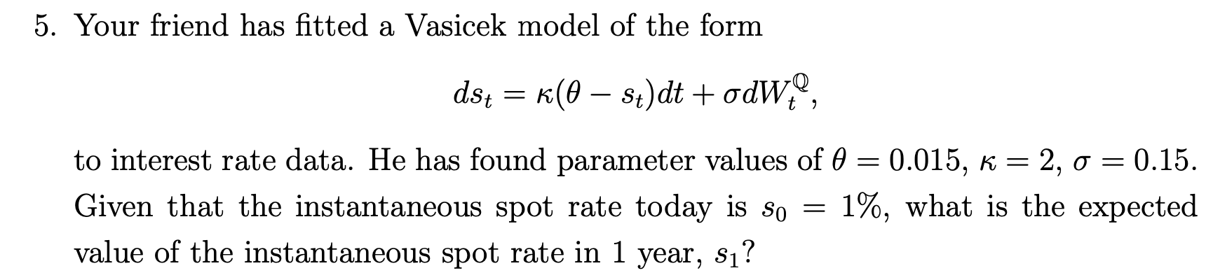
Q5
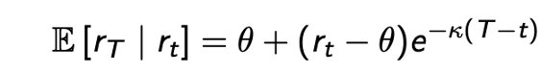
Slides give this formula
$$E\left[s_{1} | s_{0}=0.01\right]=0.015+\left(0.01-0.015\right)·e^{-2}=0,015-0,005·e^{-2}≈0,0143233$$

Exercise 4
Q1
First is simply applying the BSM call option formula
$$σ=0.3$$
$$r=0.04$$
$$S=100$$
$$K=85$$
$$T=1$$

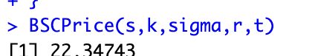

Q2
We check boundary conditions and the BSM formula
Boundary, namely $t=T$
$$V_{T}=e^{(σ^{2}-2r)(T-T)}·\frac{1}{S}=1·\frac{1}{S}$$
Tjek
Then we only need to tjek the BSM formula
$$r·f\left(t,S\right)=\frac{∂f}{∂t}\left(t,S\right)+r·S·\frac{∂f}{∂S}\left(t,S\right)+\frac{1}{2}σ^{2}S^{2}\frac{∂^{2}f}{∂S^{2}}\left(t,S\right)$$
$$\frac{∂V_{t}}{∂t}=-\left(σ^{2}-2r\right)·V_{t}$$
$$\frac{∂V}{∂S}=-\frac{1}{S^{2}}·e^{\left(σ^{2}-r\right)\left(T-T\right)}=-\frac{1}{S}·V_{t}$$
$$\frac{∂^{2}V}{∂S^{2}}=2·\frac{1}{S^{3}}·e^{\left(σ^{2}-r\right)\left(T-T\right)}=2·\frac{1}{S^{2}}·V_{t}$$
$$\frac{∂V_{t}}{∂t}+r·S·\frac{∂V}{∂S}+\frac{1}{2}·σ^{2}·S^{2}·\frac{∂^{2}V}{∂S^{2}}=-\left(σ^{2}-2r\right)·V_{t}+r·S·-\frac{1}{S}·V_{t}+\frac{1}{2}·σ^{2}·S^{2}·2·\frac{1}{S^{2}}·V_{t}$$
$$=-\left(σ^{2}-r\right)·V_{t}-r·V_{t}+σ^{2}·V_{t}=r·V_{t}$$
Thus the BSM equation is satisfied and no arbitrage is

Q3
We use its lemma
Call
$$X_{t}=\frac{1}{S_{t}}$$
$$\frac{∂X_{t}}{∂t}=0$$
$$\frac{∂X_{t}}{∂S_{t}}=-\frac{1}{S_{t}^{2}}$$
$$\frac{∂^{2}X_{t}}{∂S_{t}^{2}}=2·\frac{1}{S_{t}^{3}}$$
$$dX_{t}=\left[\frac{∂X}{∂t}+μ·S_{t}·\frac{∂X}{∂S}+\frac{1}{2}·σ^{2}·S^{2}·\frac{∂^{2}X}{∂S^{2}}\right]dt+σ·S·\frac{∂X}{∂S} dW_{t}$$
$$=\left[0-μ·\frac{1}{S_{t}}+\frac{1}{2}·2σ^{2}·\frac{1}{S_{t}}\right]dt-σ·\frac{1}{S_{t}} dW_{t}$$

$$=\left[-μ+σ^{2}\right]X_{t} dt-σ·X_{t} dW_{t}$$
Q4
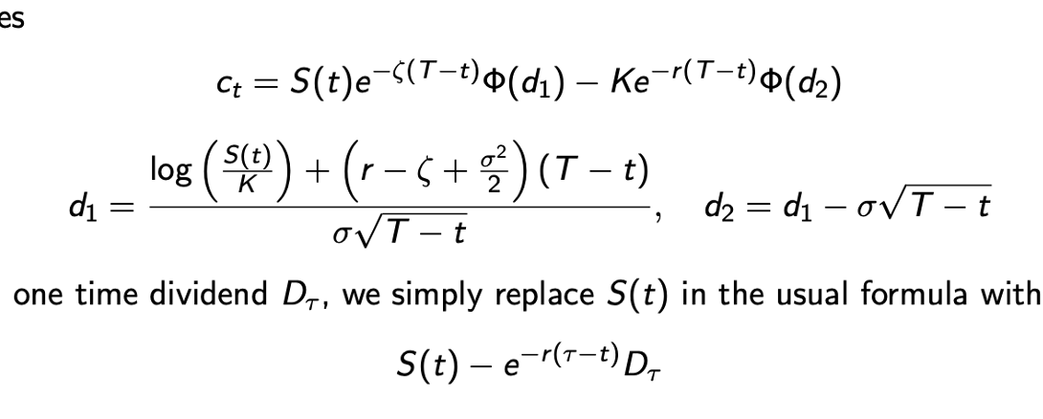
$$σ=0.3$$
$$r=0.04$$
$$S=100$$
$$K=85$$
$$T=1$$
$$δ=0.02$$

$$d_{1}=\frac{\log\left(\frac{100}{85}\right)+\left(0.04-0.02+\frac{{0.3}^{2}}{2}\right)·1}{0.3·1}=3,3333333·\log\left(\frac{20}{17}\right)+0,2166667≈0,4519369$$
$$d_{2}=0,4519369-0.3≈0,1519369$$
$$C_{t}=100·e^{-0.02}·\int_{-∞}^{0,4519369}{\frac{1}{\sqrt{2·π}}·e^{-\frac{x^{2}}{2}}dx}-85·e^{-0.04}·\int_{-∞}^{0,1519369}{\frac{1}{\sqrt{2·π}}·e^{-\frac{x^{2}}{2}}dx}=49,0099337·\operatorname{erf}\left(\frac{4519369}{78125·2^{\frac{15}{2}}}\right)-40,8335512·\operatorname{erf}\left(\frac{1519369}{78125·2^{\frac{15}{2}}}\right)+8,1763825≈20,3342444$$

Q5
As stated we repelace the actual current rpice with
$$100-10·e^{-0.04·0.5}≈90,1980133$$
Ill be rouding to 90.20
